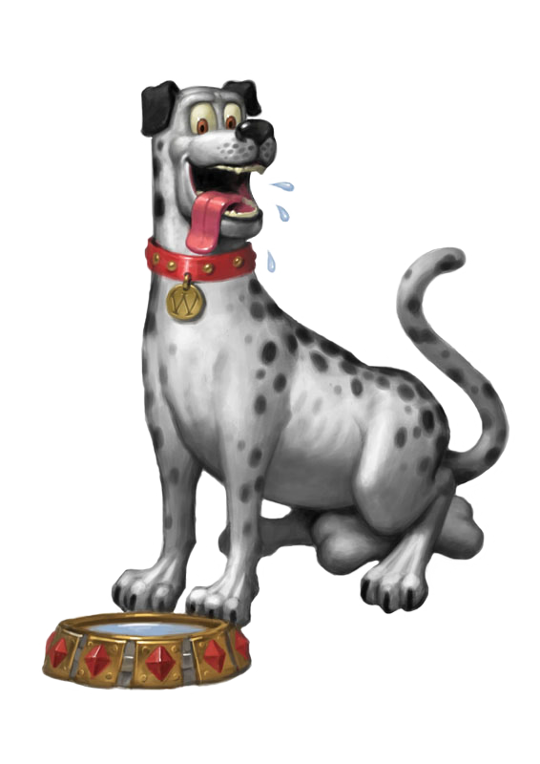
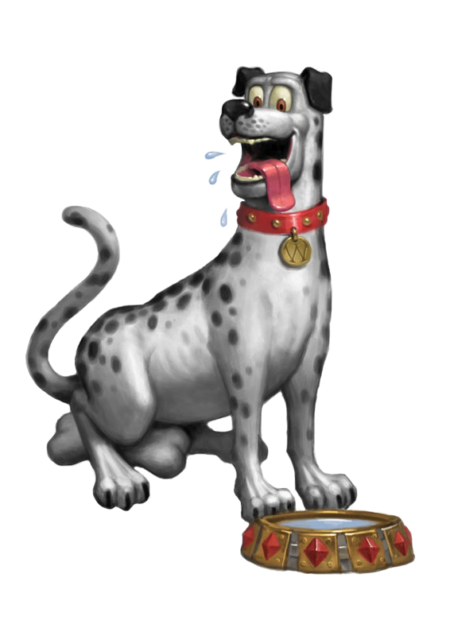
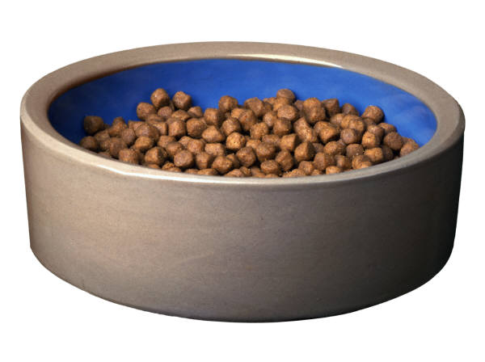

All DOGS members are invited to participate in the 1st UK event for 2012
Friday April 20th
Breakfast 10.00
Tee Time 11.00
Chipping Norton Golf Club
Dinner 19.30 Tiddington Cricket Club
£40
All normal rules
+
The Inaugural
DOGS Bowl
Tiddington (+Albury & Milton Common)
Vs
Rest of the World

